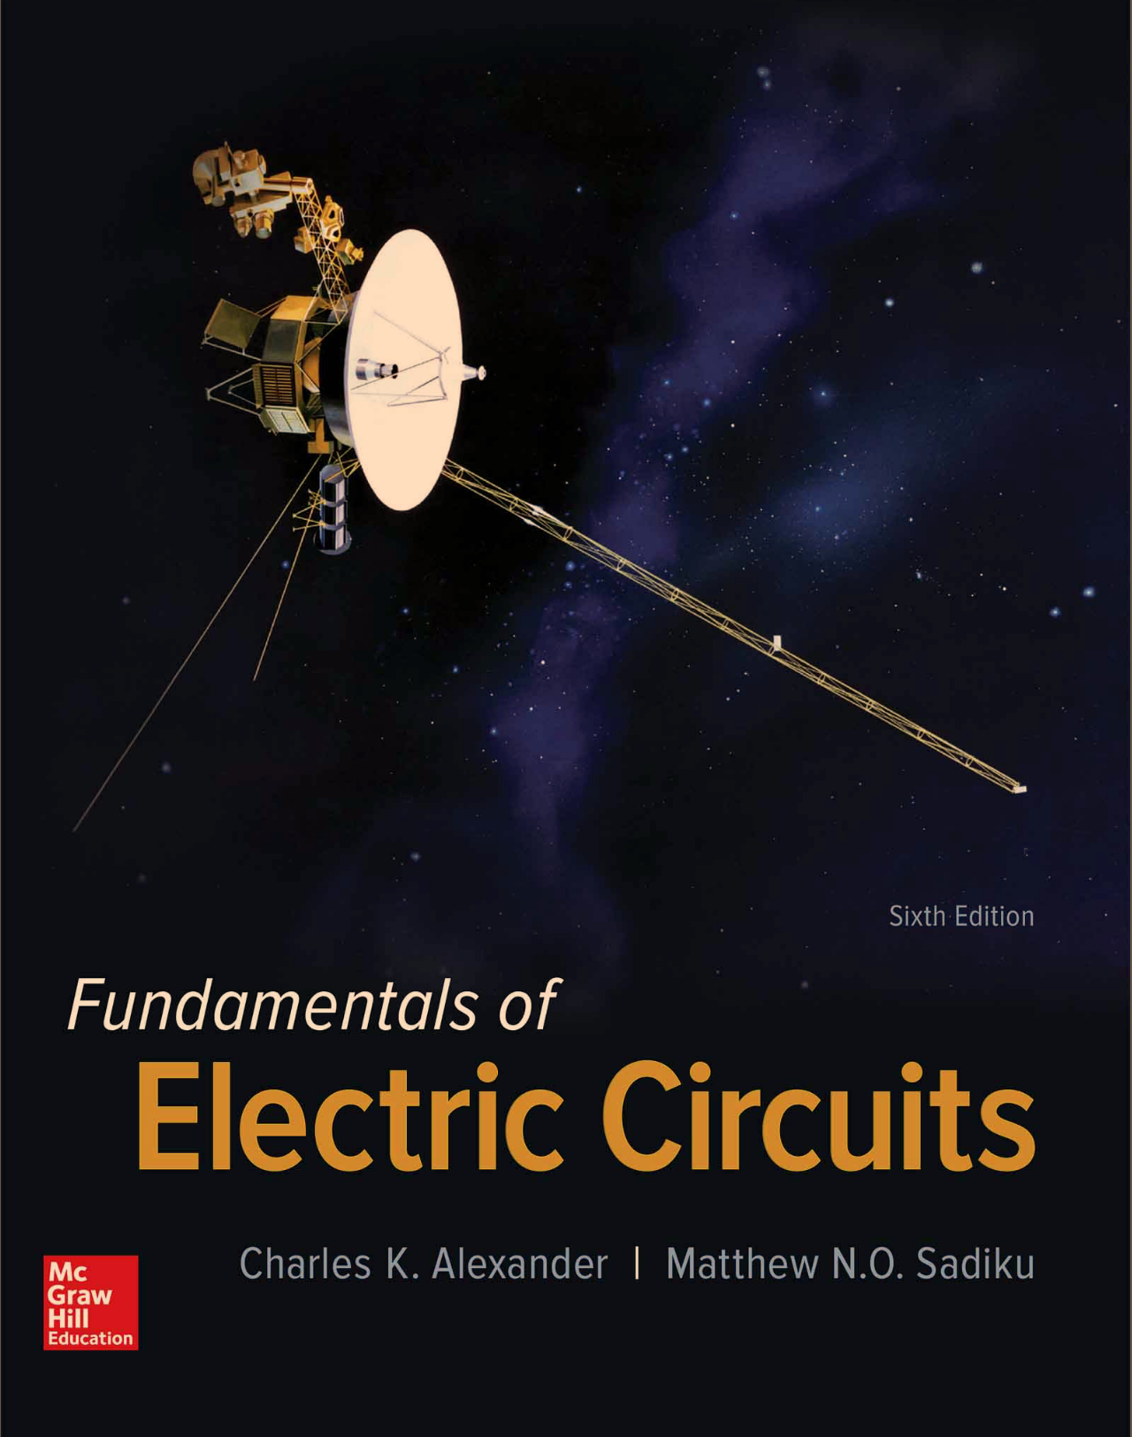

1. Please solve and write the answer to all of the given **Practice Problem 8.1, 8.3, and 8.4** in handwriting. And take a picture for the solutions and attach the picture to the assignment file.